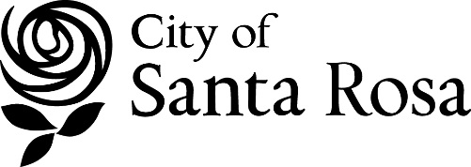

NOTICE OF PUBLIC COMMENT PERIOD
2017/2018 Consolidated Annual Performance and Evaluation Report
(CAPER)

The City of Santa Rosa has prepared a draft Consolidated Annual Performance and Evaluation Report (CAPER) for Fiscal Year 2017/2018. This document reports on the progress made in the U.S. Department of Housing and Urban Development (HUD) Community Development Block Grant (CDBG) and HOME Investment Partnerships (HOME) programs. Additionally, the City has prepared a CAPER for the Housing Opportunities for Persons with AIDS (HOPWA) program.

Beginning September 1, the CAPERs will be available for public comment. The CAPERs will be available electronically on the City’s website at https://srcity.org/767/State-Federal-Reports.
Hard copies will be available at the Department of Housing and Community Services located at the City Hall Annex at 90 Santa Rosa Avenue; the City Manager’s Office located in City Hall, 100 Santa Rosa Avenue, Room 10; and the Main Branch of the Sonoma County Public Library located at 4th and E Streets.

The public comment period runs from September 1 through September 16, 2018.

Comments may be sent to:

Nancy Manchester, Program Specialist II
Department of Housing and Community Services
City of Santa Rosa
90 Santa Rosa Avenue
Santa Rosa, California 95404
707-543-4339
NManchester@srcity.org

 | The City of Santa Rosa does not discriminate on the basis of disability in the admissions or access to, or treatment of or employment in, its programs or activities. Disability-related aids or services, including printed information in alternate formats, to enable persons with disabilities to participate in public meetings and programs are available by contacting the Administrative Secretary at (707) 543-3300 one week prior to the meeting/program.

This information can also be accessed via the internet at: http://www.srcity.org.

